Zurich Dada

Dada began in the midst of World War I in Zurich, Switzerland where several expatriate artists converged in order to escape the brutal and seemingly nonsensical destruction of the war. They responded in turn with nonsense, creating an anarchic and subversive anti-aesthetic that would have profound effects on the history of the avant-garde. Indeed, nearly every major Western art movement since the 1920s, as well as culture jammers of all kinds, can claim some connection to the Zurich Dadaists. They initially met at the Cabaret Voltaire - named after the French Enlightenment philosopher - which was opened by theater director Hugo Ball and his partner, the performer Emmy Hennings, on 5 February 1916. Until the summer of that year, the international group met nightly in a charged Dionysian atmosphere where an audience of fellow expats and dissidents experienced a provocative mix of sound and simultaneous poetry in different languages, Cubist dances with African masks, as well as readings from Expressionist and Futurist texts, from Voltaire, and from the artists’ own manifestoes. Works by Hans Arp and Otto van Rees hung on the walls. The Dadaists violently rejected the values of Western art and culture, which they believed had contributed to the outbreak of war in the first place. They were especially against the ideas of beauty, mimesis, the myth of originality, the truth of reason, and the transparency of communication.

In order to avoid being drafted, Hennings forged Ball’s passport in 1915 and they crossed from Germany into neutral Switzerland. In Zurich, they met the artist Hans Arp and dancer Sophie Taeuber at Galerie Tanner in November of that year. The Romanian poet Tristan Tzara and his compatriot, architectural student and painter Marcel Janco, joined the group after responding to a press announcement for the new Cabaret. Richard Huelsenbeck, who had collaborated with Ball in Berlin, arrived shortly thereafter, rounding out the original members of Zurich Dada.

The name Dada - which was conceived between the opening night of the Cabaret Voltaire and the publication of a periodical of the same name in June 1916 - itself highlights some important aspects of the movement. Against the growing nationalisms of the time, it emphasizes the international nature of the group since the word has connotations in German (the child’s fort-da game as described by Freud), French (‘hobbyhorse’), and Romanian (‘yes, yes’). It also brings attention to the role of chance in the Dada anti-aesthetic, in contrast to the old ideas of artistic intention or even genius: in Huelsenbeck’s account of the word’s origin, he and Ball simply plunged a knife blindly into a dictionary. Finally, it points to the growing rivalry between Huelsenbeck and Tzara, who would later claim to have invented the name. This internal tension eventually drove Ball from the group. Additionally, Huelsenbeck left for Germany at the end of 1916, where he would contribute to the Berlin Dada movement, leaving Tzara as the de facto leader of the Zurich Dadaists in their new venue at Galerie Dada. Subsequently, Tzara facilitated the publication of several more periodicals under the title Dada and inspired other Dada groups around Europe through his incessant networking. But after the war, the refugee artists were again free to travel, bringing the Zurich chapter of Dada to an end. Arp joined Max Ernst in Cologne while Tzara followed Francis Picabia to Paris, where Dada would continue to flourish before it gave way to Surrealism in 1924.

References and further reading

Arp, J. (1972), Arp on Arp: Poems, Essays, Memories, ed. Marcel Jean, New York: Viking Press.

Ball, H. (1996), Flight out of Time: A Dada Diary, ed. John Elderfield, Berkeley: University of California Press.

Huelsenbeck, R. (1991) Memoirs of a Dada Drummer, Berkeley: University of California Press.

Motherwell, R (1989), ed., The Dada Painters and Poets: An Anthology, Cambridge: Harvard University Press.

Richter, Hans (1997), Dada: Art and Anti-Art, London: Thames & Hudson.

Suggested images

Anonymous photograph of Marcel Janco’s Cabaret Voltaire, 1916, dimensions unknown (lost work). <http://frieze-magazin.de/archiv/features/kuenstlerische-selbstenthuellung/?lang=en>

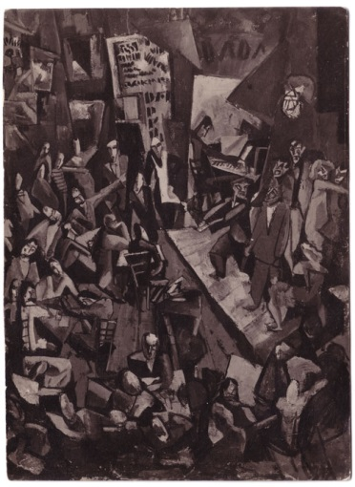



Sophie Taeuber dancing at the opening of Galerie Dada, 29 March 1917

La Fondation Arp, <http://www.fondationarp.org>/

